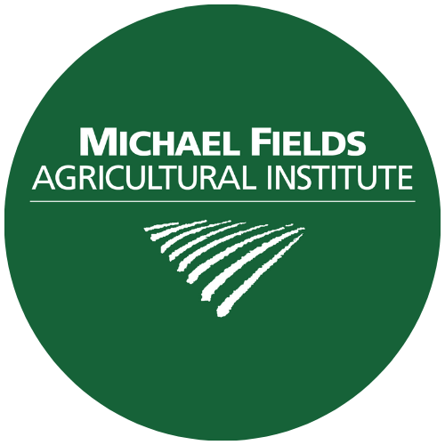

Designing A Project for Federal Funding

A well-conceived federally funded project, whether a research, conservation, marketing or other proposal, is no different from any other good project.

• It has tightly defined purposes,

• a clear strategy to accomplish them,

• on a defined and realistic timeline,

• the people, money, and other resources needed to accomplish them,

• a basis for evaluating the process when done,

• and an effective means of communicating results to any audience that
needs to hear them.

• Many projects are strengthened by thoughtfully built supporting coalitions.

• Good projects use existing resources to leverage additional ones. Funders often favor or require matches of funding as an indicator of local commitment to a project. Matches usually can be "in-kind" contributions (e.g., volunteer labor, existing equipment, etc.), as well as actual dollars (“cash match”).

Prerequisites to Designing a Good Project

• Include only active stakeholders in the planning process.

• Give yourself enough time. Setting project goals, objectives, strategies, timelines, budgets, evaluation processes, especially in a group, takes time.

• Be sure to ask the right questions and answer them carefully. (See next page)

Questions to Consider in Developing a Project

• What's the problem you seek to address?

• Have other people, locally or elsewhere, addressed this problem? If so,
what have you learned from their work, and how does your effort
relate to theirs?

• Who else might be concerned about your issues? Should they be involved
in your project? What will they contribute?

• What is your principal strategy to resolve that problem? Why is this
strategy better than other approaches you might consider?

• What's a realistic timeline, for action?

• What resources do you need to implement your project? What resources
can you and other stakeholders offer for a non-federal match?

• Would others profit from knowing about your initiative? If so, are they
local, regional, national? What’s the best way to get the word out to
that audience?

• How will you measure and evaluate your project's outcomes? Keep in mind
how to assess your work impartially against both your project’s goals
and its measurable objectives.

An MFAI Grants Adviser can help you identify funding opportunities suitable to your unique situation and goals. They will help you identify a program that best fits your goals and help you outline a plan of work for you to follow to meet the application deadline and all application requirements. Examples might be federal, state or local loan programs, loan guarantees, or other non-traditional funding options. Learn more at www.michaelfields.org

